CLASS TEST-1

# Write a program to print the numbers from M to N by skipping K numbers in between?

import java.util.Scanner;

public class NumberPrinter {

public static void main(String[] args) {

Scanner scanner = new Scanner(System.in);

System.out.print("Enter the starting number (M): ");

int start = scanner.nextInt();

System.out.print("Enter the ending number (N): ");

int end = scanner.nextInt();

System.out.print("Enter the number of skips (K): ");

int skip = scanner.nextInt();

for (int i = start; i <= end; i += skip + 1) {

System.out.println(i);

}

scanner.close();

}

}

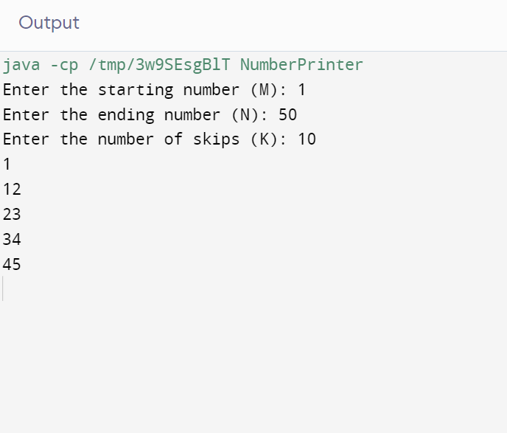

# Java Program to Find Even Sum of Fibonacci Series Till number N?

import java.util.Scanner;

public class FibonacciEvenSum {

public static void main(String[] args) {

Scanner scanner = new Scanner(System.in);

System.out.print("Enter the value of N: ");

int n = scanner.nextInt();

int first = 0;

int second = 1;

int sum = 0;

while (second <= n) {

if (second % 2 == 0) {

sum += second;

}

int next = first + second;

first = second;

second = next;

}

System.out.println("The sum of even Fibonacci numbers up to " + n + " is: " + sum);

}

}

